{{Project Name}}

# Project Details

Write few lines of details about the business problem you are trying to implement or solve.

# GitHub URL

www.github.com/........

# Team Members:

|  |  |
| --- | --- |
| Student ID | Student Name |
|  |  |
|  |  |
|  |  |

# NoSQL Database Information

Database Name:

|  |  |  |
| --- | --- | --- |
| Collection Name | Collection Details and #of Documents available | Team Member(s) worked on it |
| Product |  |  |
| Warehouse |  |  |
| Customer |  |  |
| Supplier |  |  |
| Order |  |  |
| Employee |  |  |
|  |  |  |

Database backup file: Attach your database backup file here so that it can be restored and used.



# NodeJS Service Information

|  |  |  |
| --- | --- | --- |
| Service Path for customer | Details | Team Member(s) worked on it |
| http://localhost:8081/api/customer1 | This service method is used to read data using GET Services. |  |
| http://localhost:8081/api/customert2 | In this we have used POST Services to insert data |  |
| http://localhost:8081/api/cutomer33 | The Delete method is used to delete one document. |  |
| http://localhost:8081/api/customer4 | In this service with the put command we have updated the document. |  |
| Service Path for product | Details | Team Member(s) worked on it |
| http://localhost:8081/api/product1 | This service method is used to read data using GET Services. |  |
| http://localhost:8081/api/product2 | In this we have used POST Services to insert data |  |
| http://localhost:8081/api/product3 | The Delete method is used to delete one document. |  |
| http://localhost:8081/api/product4 | In this service with the put command we have updated the document. |  |
| Service Path for supplier | Details | Team Member(s) worked on it |
| http://localhost:8081/api/supplier1 | This service method is used to read data using GET Services. |  |
| http://localhost:8081/api/suppliert2 | In this we have used POST Services to insert data |  |
| http://localhost:8081/api/supplier3 | The Delete method is used to delete one document. |  |
| http://localhost:8081/api/supplier4 | In this service with the put command we have updated the document. |  |
| Service Path for warehouse | Details | Team Member(s) worked on it |
| http://localhost:8081/api/warehouse1 | This service method is used to read data using GET Services. |  |
| http://localhost:8081/api/warehouse2 | In this we have used POST Services to insert data |  |
| http://localhost:8081/api/warehouse3 | The Delete method is used to delete one document. |  |
| http://localhost:8081/api/warehouse4 | In this service with the put command we have updated the document. |  |

Service Codes: Attach the NodeJS code package here.



# Application or Website details

Provide screen shot with details.

a). Creating web page using GET Services-

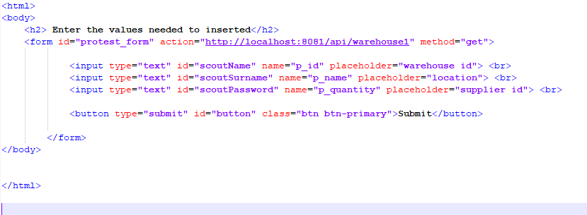

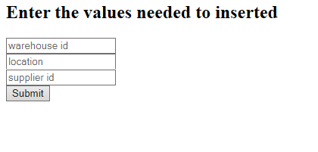

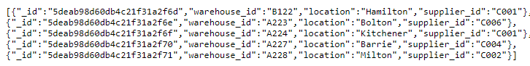

b). Creating web page using POST Services-

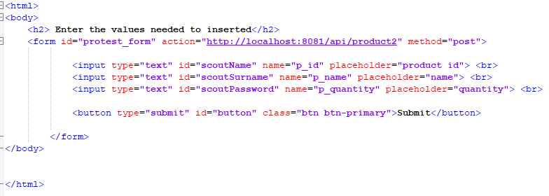

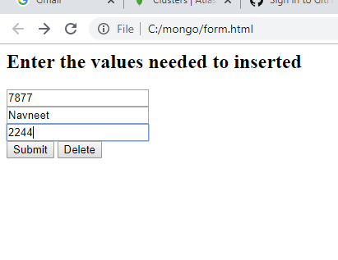

Attach the codes.

# How this application will be deployed into Cloud?

Write in details

# Score Distribution

# Score Distribution

|  |  |  |  |  |  |
| --- | --- | --- | --- | --- | --- |
| Module | Total Marks | Student 1 | Student 2 | Student 3 | Student 4 |
| NoSQL Database | 8 |  |  |  |  |
| NodeJS Service | 8 |  |  |  |  |
| Application | 8 |  |  |  |  |
| Cloud Deployment Details | 8 |  |  |  |  |
| GitHub | 4 |  |  |  |  |
| Participation | 4 |  |  |  |  |
| Total | 40 |  |  |  |  |